**TEST PLAN**

**BARANGAY SOUTH SIGNAL VILLAGE WEP APP**

**Status**: Initial Draft

Table of Contents

**1. INTRODUCTION** 4

**1.1. Purpose** 4

**1.2 Project Overview** 4

**1.3 Audience** 4

**2. TEST STRATEGY** 4

**2.1 Test Objectives** 4

**2.2 Test Assumptions** 5

**2.3. Test Principles** 5

**2.4. Data Approach** 6

**2.5. Scope and Levels of Testing** 6

**2.5.1. Exploratory Testing** 6

**2.5.2 Functional Testing** 6

**2.5.3**  **User Acceptance Testing** 6

**3. TEST AREAS AND SPECIFICATION** 7

**3.1 Features to be tested** 7

**4. EXECUTION STRATEGY** 7

**4.1 Entry and Exit Criteria** 7

**4.1.1 Entry Criteria** 7

**4.1.2 Exit Criteria** 8

**4.2 Test Cycles** 8

**4.3 Validation and Defect Management** 9

**4.4 Test Metrics** 9

Test metrics will be created and shared with the project manager for approval to track the test's development and level of success. The below are some of the metrics: 9

**4.5 Defect Tracking and Reporting** 10

**5. TEST MANAGEMENT PROCESS** 11

**5.1. Test Management Tool** 11

**5.2. Test Design Process** 11

**5.3. Test Execution Process** 12

**5.4. Test Risks and Mitigation Factors** 12

• Human Error- one of the causes for human error is that the employee lacks training. They don’t know what certain button does or to navigate the web app 13

**5.5 Communications Plan and Team Roster** 13

**5.6 Role Expectations**  13

**5.6.1. Test Planning** 13

**5.6.2 QA Engineer** 13

**5.6.3 QA Test Analyst** 13

**5.6.4 QA Team Lead** 14

**5.6.5 QA Manager** 14

**6.** **TEST ENVIRONMENT** 14

# **1. INTRODUCTION**

## **1.1. Purpose**

This test plan aims to establish a comprehensive understanding of the processes needed in testing the Barangay Sout Signal Village Web Application – which includes test procedures, test execution, and management, to ensure that functionality and performance criteria meet the overall business requirements of the client. Also, this includes the records and documentation such as test cases, test strategies, and other expected results during the entirety of the testing phase.

## **1.2 Project Overview**

The Barangay South Signal Village Web App is a web application that will eliminate manual transactions, which can help in saving time in processing the data and ensures accurate data information of an individual. The project aims to digitalize the barangay processes by introducing online forms which will minimize typographical errors by 90% and automation of information to be filled in the form will reduce the processing time for the residents. Utilizing the process through digitalization, the physical interactions and transactions will be minimized, as residents will receive the documents according to scheduled deliveries.

## **1.3 Audience**

* **Project Manager** – the project team leader responsible for supervising effective project planning and its execution. Formulates a comprehensive project strategy and sets clear project objectives. Also, maintain communication with the client, providing updates on the project's status and progress.
* **Product Owner** - the Product Owner holds the responsibility of organizing the project requirements and the final product must meet the Project Sponsors’ expectations. To guarantee that the deliverables are aligned with the scope, the Project Manager and Scrum Team collaborate effectively.
* **QA team** – the QA team will be the ones responsible in handling the testing process, starting from requirements gathering, validation of data, verification, testing phases and cycles, as well as communicating the results of the test processes to the approvers of the project (i.e., the project manager)

# **2. TEST STRATEGY**

## **2.1 Test Objectives**

This project seeks to resolve the challenges of manual transactions experienced by the residents of Barangay South Signal Village. This web application is developed to offer a user-friendly online service to the barangay community.

Here is the test list of the final product:

* A web application that is ready for deployment and production
* Various reusable documentation and reports on how the web application is tested for re-doing tests – functional, performance, user acceptance – in the future.

## **2.2 Test Assumptions**

**Key Assumption:**

* The necessary test data required for the web application is ready and available before the exploratory testing.
* Upon each testing phase, the most recent test cycle would improve upon the preceding one.

**Functional Testing**

* The testing team is responsible for testing the Barangay South Signal Village Web App – Admin Modules only.
* The testing team will use the test data available before and during the test execution.
* Bugs or errors would be documented and reported to the developing team
* The test would be done in a local host environment to prevent 3rd party users from joining during the testing phase.
* The QA team would meet with the development team to discuss all the critical errors found in the web app.

## **2.3. Test Principles**

* Testing will go through each phase, ensuring all aspects of the system are complete and aligned with the requirements. Testing will be executed with specific guidelines and procedures
* Testing the project to check the overall quality of the system and ensure it provides a user-friendly experience and beneficial experience to the residents. Testing will be done thoroughly to ensure the quality of service it provides to the residents and users in general.
* Testing the system in the early stage and verifying the functionality of the system to resolve any issues. Testing the system to ensure its functionality and follows its business objectives
* Testing will include team collaboration within the team to update the progress of the testing and shared common understanding during the testing phase.
* Testing will be done according to the phase to achieve the desired objectives
* Testing will be done repeatedly to measure its functionality
* Testing will be documented on each step
* Bugs or defects found during the testing will notify the developing team promptly

## **2.4. Data Approach**

* The Barangay South Signal Village Web App is expected to have pre-loaded data that can be used for functional testing.

## **2.5. Scope and Levels of Testing**

### **2.5.1. Exploratory Testing**

**PURPOSE:** the purpose of exploratory testing is to scope the potential and visible defects that has critical impact before the overall functional testing

**SCOPE:** Website navigation, checking the admin modules

**TESTERS:** Testing Team

**METHOD:** The exploratory testing is done without automation tools for testing

### **2.5.2 Functional Testing**

**PURPOSE:** the purpose of functional testing is to scope the admin-module functions of the web app, ensuring that all the functions and features met the criteria set from the software requirements.

**SCOPE:** Website navigation, checking the admin modules functionalities

**TESTERS:** Testing Team

**METHOD:** The functional testing is done using Selenium IDE

### **2.5.3 User Acceptance Testing**

**PURPOSE:** the purpose of user acceptance testing is to scope the admin-module functions of the web app, ensuring that all the functions and features met the criteria set from the business requirements of the client, and that the system functions as how it is intended to work for the user.

**SCOPE:** Website navigation, checking the admin modules functionalities

**TESTERS:** Testing Team

**METHOD:** The user acceptance testing is done using Selenium IDE

# **3. TEST AREAS AND SPECIFICATION**

## **3.1 Features to be tested**

|  |  |  |
| --- | --- | --- |
| Use Case No. | Use Case Name | Test Type |
| UC1.1 | Log-in Barangay Employee Account | Exploratory, Functional, UAT |
| UC2.1 | Admin - Create Employee Account | Exploratory, Functional UAT |
| UC2.2 | Admin – Deactivate Employee Account | Exploratory, Functional, UAT |
| UC2.3 | Admin – Reactivate Employee Account | Exploratory, Functional, UAT |
| UC2.4 | Admin – Edit Employee Account | Exploratory, Functional, UAT |
| UC2.5 | Employee – Edit Employee Account | Exploratory, Functional, UAT |
| UC3.1 | Deactivate Resident Account | Exploratory, Functional, UAT |
| UC3.2 | Reactivate Resident Account | Exploratory, Functional, UAT |
| UC4.1 | Edit Homepage Banner | Exploratory, Functional, UAT |
| UC4.2 | Edit Demography | Exploratory, Functional, UAT |
| UC4.3 | Edit Contacts | Exploratory, Functional, UAT |
| UC4.4 | Edit Barangay Officials | Exploratory, Functional, UAT |
| UC5.1 | Manage Services | Exploratory, Functional, UAT |
| UC5.2 | View Document Request | Exploratory, Functional, UAT |
| UC5.3 | Process Document Request | Exploratory, Functional, UAT |
| UC5.4 | Approve Document Request | Exploratory, Functional, UAT |
| UC5.5 | Deny Document Request | Exploratory, Functional, UAT |
| UC6.1 | View Concern | Exploratory, Functional, UAT |
| UC6.2 | Process Concern | Exploratory, Functional, UAT |
| UC6.3 | Update Concern | Exploratory, Functional, UAT |
| UC6.4 | Deny Concern | Exploratory, Functional, UAT |
| UC6.5 | Close Concern | Exploratory, Functional, UAT |
| UC7.1 | Barangay Data Report | Exploratory, Functional, UAT |

# **4. EXECUTION STRATEGY**

## **4.1 Entry and Exit Criteria**

### **4.1.1 Entry Criteria**

Listed below are the criteria that will be used as entry criteria for testing the Barangay South Signal Village Web Application:

|  |  |  |  |
| --- | --- | --- | --- |
| **Entry Criteria** | **Test Team** | **Technical Team** | **Notes** |
| * The documentation for software and business requirements are available |  | Checkmark with solid fill |  |
| * The web application is available and ready for testing |  | Checkmark with solid fill |  |
| * The setup of the environment for testing is already complete | Checkmark with solid fill |  |  |
| * The test data are available |  | Checkmark with solid fill |  |
| * The test plan and test strategy are approved | Checkmark with solid fill |  |  |
| * Test scenarios and conditions are approved | Checkmark with solid fill |  |  |
| * Test Scripts are ready and approved | Checkmark with solid fill |  |  |

### **4.1.2 Exit Criteria**

Listed below are the criteria that will be used as exit criteria for testing the Barangay South Signal Village Web Application:

|  |  |  |  |
| --- | --- | --- | --- |
| **Exit Criteria** | **Test Team** | **Technical Team** | **Notes** |
| * The target date for the testing process is spent | Checkmark with solid fill |  |  |
| * The test plan is executed, and the test cases are all done | Checkmark with solid fill |  |  |
| * The requirements and functionalities which were tested with actual results met at least 90% of the expected outcome and are all recorded through the test scripts | Checkmark with solid fill |  |  |
| * All the critical defects are resolved or are a discussion subject for change in future releases |  | Checkmark with solid fill |  |
| * Non-critical or low-priority defects are mitigated and are under control and will not have an impact on the deployment of the application |  | Checkmark with solid fill |  |
| * Test Closure Memo is completed | Checkmark with solid fill |  |  |
| * Test Sign-off Sheet is completed and approved | Checkmark with solid fill |  |  |

## **4.2 Test Cycles**

* There will be only one cycle for each testing phase.
* Each phase consists of exploratory, functional, and UAT.
* The objective of the first testing is to just surf through the web application and spot any bugs along the way.
* The 2nd objective of the 2nd phase is to explore the functionality of the web app. The reason behind this phase is to check if the web app is 100% functional and working according to software requirements.
* The 3rd objective for the 3rd phase is to check if the user standards are met.

## **4.3 Validation and Defect Management**

* The testers will anticipate running all the scripts in every cycle. However, the tester may perform or conduct additional testing in case there are possible script gaps. If gaps are identified, the team must review the problem. Also, script traceability and matrix will require an update, and documentation reports will be provided.
* The technical team will need detailed documentation for defects, which will help the team to analyze errors that will serve as a record that may be utilized for resolving the issues over time. Also, the technical team can request additional data information from the QA Analyst for clarification that will address the issues.

## **4.4 Test Metrics**

## Test metrics will be created and shared with the project manager for approval to track the test's development and level of success. The below are some of the metrics:

|  |  |  |
| --- | --- | --- |
| **Report** | **Description** | **Frequency** |
| **Test preparation & Execution Status** | Provide progress reports during execution. | Update Weekly/Daily (optional) |
| **Daily Execution Status** | Provides daily report for any identified defects | Update Daily |
| **Project Weekly Status Report** | Provides updates for the testing team | Update weekly if needed, utilizing a template provided by the project team. |

## **4.5 Defect Tracking and Reporting**

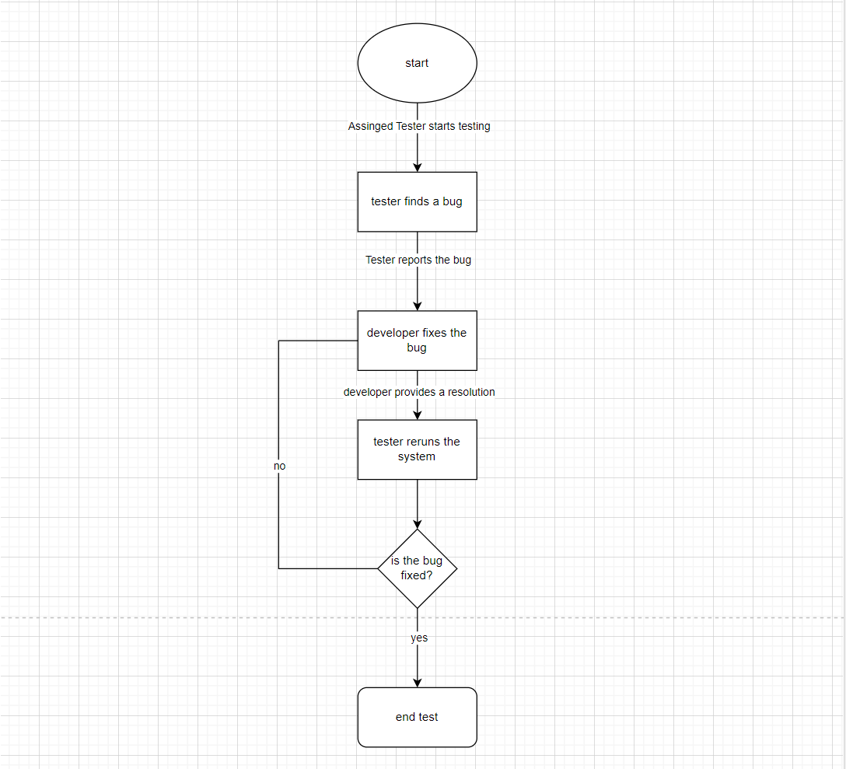

* The assigned tester would check the whole web app’s functionality and look for defects or bugs that can affect the web app’s quality of service.
* The test would then report it to the head of developing team along with documents that serves as receipt of transparency and clear communication with the collaborating team.
* The developer would then provide a resolution to the defect or bug that has been reported to by testing team.
* The tester would re-run the system to fully verify if the solution was effective or if the developing needs to come up with a new solution.

# **5. TEST MANAGEMENT PROCESS**

## **5.1. Test Management Tool**

* **Selenium IDE -** The team utilizes Selenium IDE as the test management tool for the functional and user acceptance testing process of Barangay South Village Web App, an essential tool for the tester that ensures every step of the testing process including activities that are performed during the testing will be recorded and troubleshooted to efficiently. identify issues.
* **Test Link –** An open-source management platform for the QA teams to manage quality assurance requirements such as test cases, scenarios, scripts, and execution. It helps in organizing and managing the test cases, which allows the QA teams to produce quality assurance requirements and keep track of their activity throughout testing process.

## **5.2. Test Design Process**

* The testing team will be gathering the requirements for testing, such as ensuring that the application is ready, there is available test data, and the test environment is complete.
* The testing team will document a test plan/strategy that will be approved by the project owner.
* The test cases from the test plan will be ensured that it is connected to the requirements traceability matrix.
* The test cases/scenarios/cycles prepared by the testing team will be reviewed and must be approved by the project owner.
* Revisions will be done after the review of the test planning.

## **5.3. Test Execution Process**

* **Each of the task listed from the test cases are thoroughly executed**
* **As each test case are being done, they are examined in what criteria they match. (pass or fail)**
* **With the discovered result, they are documented and sent to the developing team so that they can fix the test cases that are marked fail**
* **We repeat the process until all the cases are done and marked as Pass.**

## **5.4. Test Risks and Mitigation Factors**

|  |  |  |  |
| --- | --- | --- | --- |
| **Risks** | **Probability** | **Impact** | **Mitigation Plan** |
| Human Error | Medium | Medium | Achieving the intended plan goal of reducing human errors will necessitate precise monitoring. |
| Lack of Resources | Possible | Significant | Implementing alternative approaches when faced with shortages and regularly monitoring and updating asset availability will minimize resource shortages. |
| Unpredictable Risks | Possible | Significant |  |

## Human Error- one of the causes for human error is that the employee lacks training. They don’t know what certain button does or to navigate the web app

* Lack of Resources – This pertains to things and manpower that will be needed to run the web app to its full capacity. This is also including things like internet and the devices that will be needed to run the web app
* Unpredictable Risks- these are the things that can affect the work hours that are beyond human control. One example of this is the weather. Extreme weather conditions can affect work, especially internet connectivity.

## **5.5 Communications Plan and Team Roster**

The project leader together with the team, will conduct the tests along with the client to show transparency and the progress of the work. While the test is being conducted, it shows the full functionality of the web application.

## **5.6 Role Expectations**

|  |  |  |  |
| --- | --- | --- | --- |
|  | **Roles** | **Name** | **Contact Info** |
|  | QA Engineer | Ruth Morallos | [**rrmorallos@student.apc.edu.ph**](mailto:rrmorallos@student.apc.edu.ph) |
|  | QA Test Analyst | Vincent Nacor  Patrick Cortez  Dale Joshua Domingo  Bryan Geneta | [**vanacor@student.apc.edu.ph**](mailto:vanacor@student.apc.edu.ph)  [**pacortez2@student.apc.edu.ph**](mailto:pacortez2@student.apc.edu.ph)  [**dbdomingo@student.apc.edu.ph**](mailto:dbdomingo@student.apc.edu.ph)  [**bmgeneta@student.apc.edu.ph**](mailto:bmgeneta@student.apc.edu.ph) |
|  | QA Team Lead | Allan Nefalar | [**aonefalar2@student.apc.edu.ph**](mailto:aonefalar2@student.apc.edu.ph) |
|  | QA Manager | Kieyl Ponce | [**kdponce@student.apc.edu.ph**](mailto:kdponce@student.apc.edu.ph) |
|  | Development Lead | Jakerson Bermudo | [jbbermudo@student.apc.edu.ph](mailto:jbbermudo@student.apc.edu.ph) |

### **5.6.1. Test Planning**

* Provides comprehensive instructions to prevent or resolve defects.
* Any modification that will be made to the deliverables of testing or within the system will inform the testing team promptly.

### **5.6.2 QA Engineer**

* In charge of the process of testing the web application to guarantee that the functions adhere to the quality standards.
* Provide feedback on the testing and working collaboratively with the team.

### **5.6.3 QA Test Analyst**

* Responsible for creating test plans and strategy documentation for the testing process.
* Documents the testing process to resolve any issues during the testing and to reduce risk by communicating effectively with the QA Engineer to clarify the requirements during the testing phase.

### **5.6.4 QA Team Lead**

* Provide feedback from the documentation and schedule meetings to clarify the project requirements.
* Performs approval on test cases provided by the QA Analysts to verify that they align with the project requirements and objectives.

### **5.6.5 QA Manager**

* Provides and communicates the outcome of the testing phases from the QA Team to the Project Manager and ensures that the requirements gathered from the testing are the expected output by the client.
  + 1. **Development Team**

The development team, in collaboration with the testing team, is collectively working on the Barangay South Village Web App to ensure the software's quality and alignment with its specified requirements.

* Establish effective communication for clarification regarding software requirements and gives a comprehensive understanding and precision.
* Collaborating to address identified issues encountered during the testing.
* Provides documentation to ensure transparency.
* Brainstorm ideas and strategize ways to improve solving bug related problems.

# **TEST ENVIRONMENT**

The system Barangay South Village Web app will be hosted and tested on APC SocIT Cloud Server, as well as in the local host server of the Testing Team. It will utilize both said environments to conduct its functionality in a wide and large different category to evaluate the functionality of the web app.

**Localhost-** the localhost would be the 1st line of testing grounds to see if the web app’s functionality runs as intended. If there are bugs to be found and discovered, this would be documented and immediately reported to the developing so that it can be fixed and improved as soon as possible.

**SocIT Cloud-** The SocITCloud is a testing ground that would allow to emulate the environment as if the web app is deployed in real time. This would greatly help the web app to measure how many users it can handle at the same time. This would not only help finding bugs but also check the web app’s security pain points at the same time.

1. APPROVALS

The Names and Titles of all persons who must approve this plan.

|  |  |
| --- | --- |
| **Signature:** |  |
| **Name:** | Jakerson Bermudo |
| **Role:** | Development Lead |
| **Date:** | - |

|  |  |
| --- | --- |
| **Signature:** |  |
| **Name:** | Allan Vincent Nefalar |
| **Role:** | QA Team Lead |
| **Date:** | - |

|  |  |
| --- | --- |
| **Signature:** |  |
| **Name:** | Jose Eugenio Quesada |
| **Role:** | Adviser |
| **Date:** |  |